15 Animation for Doors
Ok, in this tutorial we will be taking a deeper dive into animation.

The Boss Door
Let’s start with the boss door animation, and create some flames for it. This will indicate to the user to enter at their own risk, as danger lurks behind this door. So, let’s get to flickering a few of those fiery flames.
Open the obj_door_boss
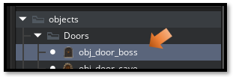
Create a Draw Event.
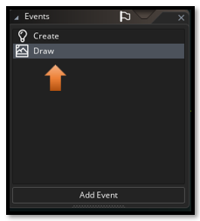
Note, Remember to drag the Boss door on to the Instance layer in the room, or you will not see it.
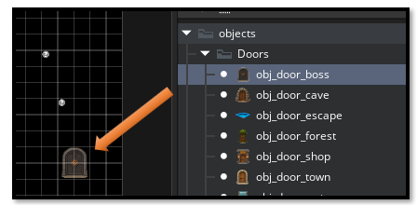

This is what the dancing flames will look like once the code is placed inside of the Draw event, and the Game is ran, to test it.
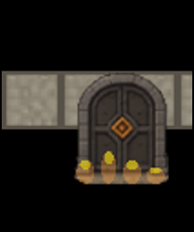

//~~~~~~~~~~~~ obj_door_boss - DRAW EVENT ~~~~~~~~~~~~~~~~~~
// Dancing flames at bottom of door

// Draw the door sprite normally
draw_self();

// --- Dancing Flame Licks ---
// Random flicker intensity
var flicker = random_range(0.7, 1.0);
// Draw flame streaks rising from bottom edges
for (var i = 0; i < 4; i++) {
// Position flames at bottom corners and sides
var flame_x = bbox_left + (sprite_width / 5) * (i + 0.5);
var flame_y = bbox_bottom;

// Random height for flame
var flame_height = random_range(8, 20);
var flame_width = random_range(3, 6);

// Draw elongated flame (vertical ellipse)
// Orange base
draw_set_color(c_orange);
draw_set_alpha(0.4 * flicker);
draw_ellipse(
flame_x - flame_width,
flame_y - flame_height,
flame_x + flame_width,
flame_y,
false
);

// Yellow tip
draw_set_color(c_yellow);
draw_set_alpha(0.5 * flicker);
draw_ellipse(
flame_x - flame_width * 0.6,
flame_y - flame_height,
flame_x + flame_width * 0.6,
flame_y - flame_height * 0.6,
false
);
}

// Reset draw settings
draw_set_alpha(1);
draw_set_color(c_white);

Test the Door

The Escape door
Next let’s try a few stars coming out of our escape door. Drag the Escape door into the room, so we can test it.
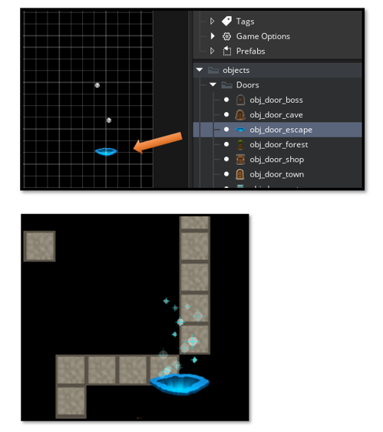

We will be using 3 Events for the Escape Door,
1. Draw Event
2. Create Event
3. Step Event

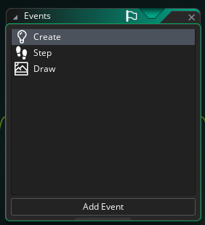

// ~~~~~~~~~~~~ obj_door_escape - DRAW EVENT ~~~~~~~~~~~~~~~~~~
// Rising stars from icy blue portal

// Draw the door sprite (blue portal)
draw_self();

// --- Draw Rising Stars ---
for (var i = 0; i < array_length(star_y); i++) {
draw_set_alpha(star_alpha[i]);

// White star with slight blue tint
draw_set_color(c_white);
draw_circle(star_x[i], star_y[i], star_size[i], false);

// Add a sparkle effect (4-pointed star)
draw_set_color(c_aqua);
draw_line_width(
star_x[i] - star_size[i] * 1.5,
star_y[i],
star_x[i] + star_size[i] * 1.5,
star_y[i],
1
);
draw_line_width(
star_x[i],
star_y[i] - star_size[i] * 1.5,
star_x[i],
star_y[i] + star_size[i] * 1.5,
1
);
}

// Reset draw settings
draw_set_alpha(1);
draw_set_color(c_white);

// ~~~~~~~~~~ obj_door_escape - CREATE EVENT ~~~~~~~~~~~~
// Initialize star particle system

depth = -100;
door_type = "escape";

// Star particle arrays
star_x = [];
star_y = [];
star_speed = [];
star_alpha = [];
star_size = [];

// Create initial stars
for (var i = 0; i < 15; i++) {
star_x[i] = x + (sprite_width / 2) + random_range(-20, 20); // Center on door
star_y[i] = y + random_range(0, 64);
star_speed[i] = random_range(0.5, 1.5);
star_alpha[i] = random(1);
star_size[i] = random_range(2, 5);
}

// ~~~~~~~~~~~~ obj_door_escape - STEP EVENT ~~~~~~~~~~~~~
// Update rising stars

// Update each star
for (var i = 0; i < array_length(star_y); i++) {
// Move star upward
star_y[i] -= star_speed[i];

// Fade in/out effect
star_alpha[i] += random_range(-0.05, 0.05);
star_alpha[i] = clamp(star_alpha[i], 0.2, 1);

// Slight horizontal drift
star_x[i] += random_range(-0.3, 0.3);

// Reset star when it goes too high
if (star_y[i] < y - 64) {
star_y[i] = y + 32;
star_x[i] = x + (sprite_width / 2) + random_range(-20, 20); // Center on door
star_alpha[i] = 0.2;
}
}

Test the Door

The Water Door
So, go to the Doors, and double click on the obj_door_water, so we can get to its code.
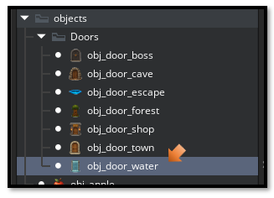
If you look at the obj_door_water, you will see that it already has a Create event associated with it. We will not be making any changes to that one though. We will need to add a Draw event to it, and all of the animation code for the Water door will be enclosed all inside of that one event.

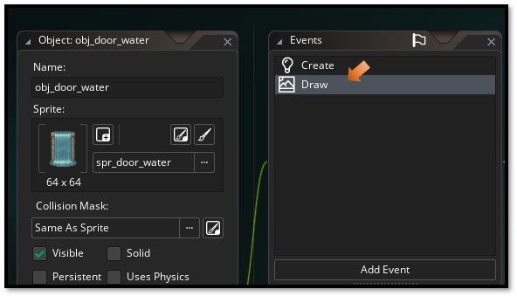
Before testing the door, remember to drag the water door object into the room.
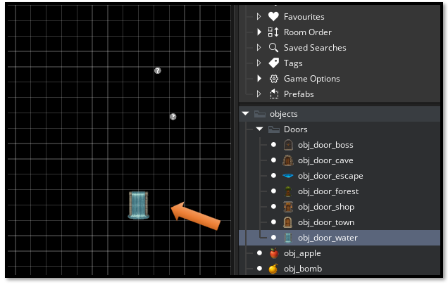

This is what the water animation will look like on the screen when we put the code in.
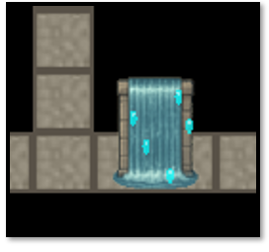

// ~~~~~~~~~~~~~~~~~~~~~~~ obj_door_water - DRAW EVENT ~~~~~~~~~~~~
// Flowing water droplets (no glow)

// Draw the door sprite normally
draw_self();

// --- Falling Water Droplets ---
var time = current_time / 100;

// Create 5 water droplets falling down (constrained to door width)
for (var i = 0; i < 5; i++) {
// Calculate droplet position within door bounds
var drop_x = bbox_left + (sprite_width * 0.2) + (sprite_width * 0.6 / 5) * i;
var drop_y = bbox_top + 8 + ((time + i * 15) % (sprite_height - 8));

// Gentle side-to-side wave motion
var wave = sin((time + i * 20) / 10) * 3;
drop_x += wave;

// Draw water droplet (vertical ellipse)
draw_set_color(c_aqua);
draw_set_alpha(0.7);
draw_ellipse(
drop_x - 2,
drop_y - 4,
drop_x + 2,
drop_y + 4,
false
);

// White highlight on top
draw_set_color(c_white);
draw_set_alpha(0.5);
draw_circle(drop_x, drop_y - 2, 1, false);
}

// Reset draw settings
draw_set_alpha(1);
draw_set_color(c_white);
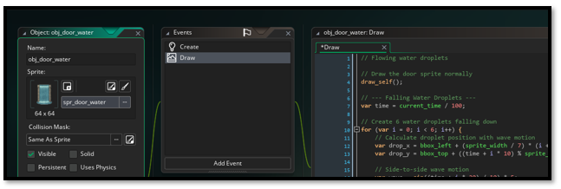

With the Code in place,
Test the Door

Forest Door
Forest door is up next - swirling magical leaves! That one will need CREATE, STEP, and DRAW events like the escape door did.
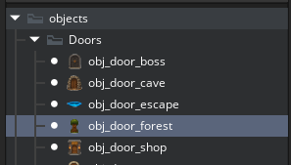
Since we already have a Create event sitting there, just add a Draw, and a Step event.
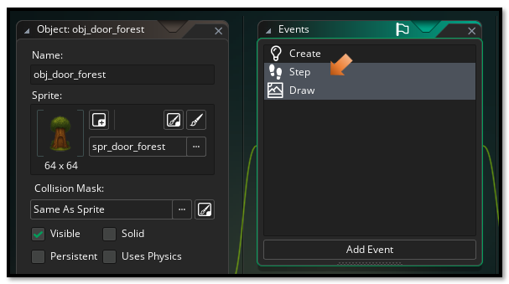

Drag the Forest Door onto the Game board
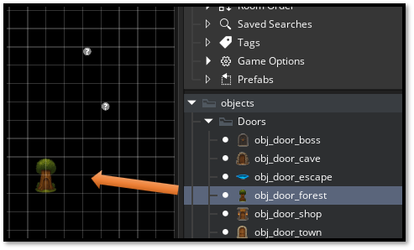
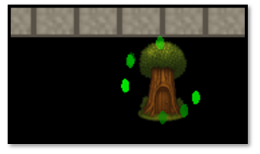
// ~~~~~~~~~~~~~~~~ obj_door_forest - CREATE EVENT ~~~~~~~~~~~~~~~
// Initialize leaf particle system

depth = -100;
door_type = "forest";

// Leaf particle arrays
leaf_x = [];
leaf_y = [];
leaf_angle = [];
leaf_speed = [];
leaf_alpha = [];

// Create initial leaves orbiting around door
for (var i = 0; i < 8; i++) {
leaf_angle[i] = (360 / 8) * i; // Evenly spaced around circle
leaf_speed[i] = random_range(0.8, 1.5);
leaf_alpha[i] = random_range(0.5, 0.8);
// x and y will be calculated in step event based on angle
}

// ~~~~~~~~~~~~~~~~~ obj_door_forest - STEP EVENT ~~~~~~~~~~~~
// Update swirling leaves

// Update each leaf
for (var i = 0; i < array_length(leaf_angle); i++) {
// Circular motion around door (tighter orbit)
var orbit_radius = 28;
leaf_angle[i] += leaf_speed[i];

leaf_x[i] = x + (sprite_width / 2) + cos(degtorad(leaf_angle[i])) * orbit_radius;
leaf_y[i] = y + (sprite_height / 2) + sin(degtorad(leaf_angle[i])) * orbit_radius;

// Gentle alpha pulse
leaf_alpha[i] += random_range(-0.02, 0.02);
leaf_alpha[i] = clamp(leaf_alpha[i], 0.4, 0.9);
}

// ~~~~~~~~~~~~~~~ obj_door_forest - DRAW EVENT ~~~~~~~~~~~~~~~~~~~~
// Magical swirling leaves

// Draw the door sprite
draw_self();

// --- Draw Swirling Leaves ---
for (var i = 0; i < array_length(leaf_angle); i++) {
draw_set_alpha(leaf_alpha[i]);

// Alternate between green colors for variety
if (i % 2 == 0) {
draw_set_color(c_green);
} else {
draw_set_color(c_lime);
}

// Draw leaf as small ellipse
draw_ellipse(
leaf_x[i] - 3,
leaf_y[i] - 5,
leaf_x[i] + 3,
leaf_y[i] + 5,
false
);
}

// Reset draw settings
draw_set_alpha(1);
draw_set_color(c_white);

Tree Animation Version 2
We could also use Png images of leaves.
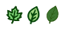
To get a good tight outline, you might have to take it in Illustrator and do a trace on it, and then shrink it down from there.
For Game Maker, you cannot use SVG, so do not save as SVG but after the trace, you and shrink down from there, you can get a better looking png.
You will only need sprites
- Import the 3 leaf PNGs as sprites:
  - spr_leaf_1 (oak leaf)
  - spr_leaf_2 (simple leaf)
  - spr_leaf_3 (pointed leaf)

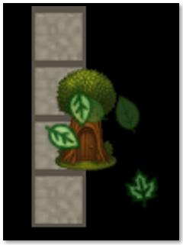

// ~~~~~~~~~~~~~~~~ obj_door_forest - CREATE EVENT ~~~~~~~~~~~~~~~
// Initialize falling leaf system with real leaf sprites

depth = -100;
door_type = "forest";

// Leaf particle arrays
leaf_x = [];
leaf_y = [];
leaf_fall_speed = [];
leaf_drift_speed = [];
leaf_rotation = [];
leaf_rotation_speed = [];
leaf_sprite = [];
leaf_alpha = [];

// Create 5 falling leaves with variety
for (var i = 0; i < 5; i++) {
// Random horizontal position within door area
leaf_x[i] = x + random_range(sprite_width * 0.2, sprite_width * 0.8);

// Start from middle/lower area of door
leaf_y[i] = y + sprite_height * 0.4 + random(sprite_height * 0.4);

// Random fall speed
leaf_fall_speed[i] = random_range(0.5, 1.2);

// Random horizontal drift
leaf_drift_speed[i] = random_range(-0.3, 0.3);

// Random starting rotation
leaf_rotation[i] = random(360);

// Random rotation speed (some spin faster)
leaf_rotation_speed[i] = random_range(-2, 2);

// Randomly assign one of the 3 leaf sprites
var leaf_choice = irandom(2); // 0, 1, or 2
if (leaf_choice == 0) {
leaf_sprite[i] = spr_leaf_1;
} else if (leaf_choice == 1) {
leaf_sprite[i] = spr_leaf_2;
} else {
leaf_sprite[i] = spr_leaf_3;
}

// Random alpha for depth
leaf_alpha[i] = random_range(0.6, 0.9);
}

// ~~~~~~~~~~~~~~~~~~~ obj_door_forest - STEP EVENT ~~~~~~~~~~~~~~~
// Update falling leaves

// Update each leaf
for (var i = 0; i < array_length(leaf_y); i++) {
// Fall downward
leaf_y[i] += leaf_fall_speed[i];

// Gentle horizontal drift
leaf_x[i] += leaf_drift_speed[i];

// Rotate the leaf as it falls
leaf_rotation[i] += leaf_rotation_speed[i];

// Gentle alpha pulse
leaf_alpha[i] += random_range(-0.01, 0.01);
leaf_alpha[i] = clamp(leaf_alpha[i], 0.5, 0.95);

// Reset leaf when it falls below the door
if (leaf_y[i] > y + sprite_height + 10) {
leaf_y[i] = y + sprite_height * 0.4; // Start from middle of door
leaf_x[i] = x + random_range(sprite_width * 0.2, sprite_width * 0.8);
leaf_rotation[i] = random(360);
}
}

// ~~~~~~~~~~~~~~ obj_door_forest - DRAW EVENT ~~~~~~~~~~~~~~~~~~~~~
// Draw falling leaf sprites

// Draw the door sprite
draw_self();

// --- Draw Falling Leaves ---
for (var i = 0; i < array_length(leaf_y); i++) {
// Draw the actual leaf sprite with rotation
draw_sprite_ext(
leaf_sprite[i], // Which leaf sprite to draw
0, // Image index (0 for non-animated)
leaf_x[i], // X position
leaf_y[i], // Y position
1, // X scale (1 = normal size)
1, // Y scale (1 = normal size)
leaf_rotation[i], // Rotation angle
c_white, // Color tint (white = no tint)
leaf_alpha[i] // Alpha transparency
);
}

// Reset draw settings
draw_set_alpha(1);
draw_set_color(c_white);

The Cave Images and the Shop Images
I just created some coins for the animation for the shop and some rocks for the animation for the Cave door.
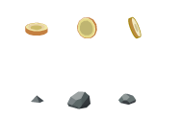

The Cave Door Animation
We want to start this just like we did the other images. Turn them into sprites, and remember to throw the cave door into the room so that we can test it.
- spr_rock_1 (small rock)
- spr_rock_2 (medium rock)
- spr_rock_3 (large rock)

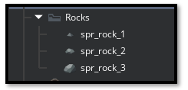
Now go up to your objects, and drag that obj_cave_door into the room
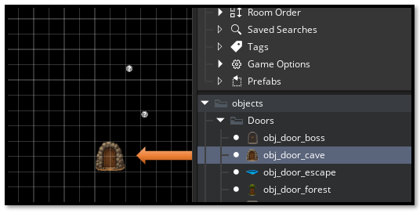
This one will take 3 different events to pull off. So, open up the obj_cave_door, so we can start writing some code.
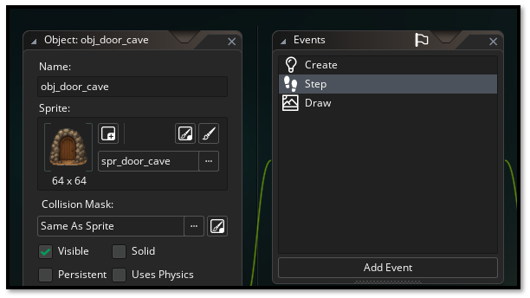

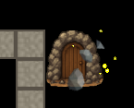

// ~~~~~~~~~~~~~~~~~~ obj_door_cave - CREATE EVENT ~~~~~~~~~~~~~~~~
// Initialize floating rocks with sparkles

depth = -100;
door_type = "cave";

// Rock arrays
rock_x = [];
rock_y = [];
rock_angle = [];
rock_rotation = [];
rock_rotation_speed = [];
rock_sprite = [];
rock_alpha = [];
rock_orbit_speed = [];

// Sparkle arrays (multiple sparkles per rock)
sparkle_x = [];
sparkle_y = [];
sparkle_rock_index = []; // Which rock this sparkle belongs to
sparkle_orbit_angle = [];
sparkle_orbit_radius = [];
sparkle_orbit_speed = [];
sparkle_alpha = [];
sparkle_size = [];

// Create 3 floating rocks
for (var i = 0; i < 3; i++) {
// Position rocks in circular orbit around door
rock_angle[i] = (360 / 3) * i; // Evenly spaced
rock_orbit_speed[i] = random_range(0.3, 0.6); // Slow float

// Random starting rotation
rock_rotation[i] = random(360);
rock_rotation_speed[i] = random_range(-0.5, 0.5);

// Assign rock sprite (rotate through all 3)
if (i == 0) {
rock_sprite[i] = spr_rock_1;
} else if (i == 1) {
rock_sprite[i] = spr_rock_2;
} else {
rock_sprite[i] = spr_rock_3;
}

rock_alpha[i] = random_range(0.7, 0.9);
}

// Create sparkles (2 sparkles per rock = 6 total)
var sparkle_count = 0;
for (var i = 0; i < 3; i++) { // For each rock
for (var j = 0; j < 2; j++) { // Create 2 sparkles
sparkle_rock_index[sparkle_count] = i; // Which rock this sparkle belongs to
sparkle_orbit_angle[sparkle_count] = random(360);
sparkle_orbit_radius[sparkle_count] = random_range(12, 20);
sparkle_orbit_speed[sparkle_count] = random_range(2, 4); // Fast orbit
sparkle_alpha[sparkle_count] = random(1);
sparkle_size[sparkle_count] = random_range(1, 3);
sparkle_count++;
}
}

// ~~~~~~~~~~~~~~~~~ obj_door_cave - STEP EVENT ~~~~~~~~~~~~~~~~~~~
// Update floating rocks and orbiting sparkles

// Update rocks floating in circle
for (var i = 0; i < array_length(rock_angle); i++) {
// Slow circular float around door center (tighter orbit)
var orbit_radius = 20;
rock_angle[i] += rock_orbit_speed[i];

rock_x[i] = x + (sprite_width / 2) + cos(degtorad(rock_angle[i])) * orbit_radius;
rock_y[i] = y + (sprite_height / 2) + sin(degtorad(rock_angle[i])) * orbit_radius;

// Slow rotation of the rock itself
rock_rotation[i] += rock_rotation_speed[i];

// Gentle alpha pulse
rock_alpha[i] += random_range(-0.01, 0.01);
rock_alpha[i] = clamp(rock_alpha[i], 0.6, 0.95);
}

// Update sparkles orbiting around rocks
for (var i = 0; i < array_length(sparkle_orbit_angle); i++) {
var rock_idx = sparkle_rock_index[i];

// Orbit around the rock
sparkle_orbit_angle[i] += sparkle_orbit_speed[i];

sparkle_x[i] = rock_x[rock_idx] + cos(degtorad(sparkle_orbit_angle[i])) * sparkle_orbit_radius[i];
sparkle_y[i] = rock_y[rock_idx] + sin(degtorad(sparkle_orbit_angle[i])) * sparkle_orbit_radius[i];

// Sparkle twinkle effect
sparkle_alpha[i] += random_range(-0.05, 0.05);
sparkle_alpha[i] = clamp(sparkle_alpha[i], 0.2, 1);
}

// ~~~~~~~~~~~~~~~~~~~~~~ obj_door_cave - DRAW EVENT ~~~~~~~~~~~~~~~
// Draw floating rocks with sparkles (no glow)

// Draw the door sprite
draw_self();

// --- Draw Sparkles (behind rocks) ---
for (var i = 0; i < array_length(sparkle_orbit_angle); i++) {
draw_set_alpha(sparkle_alpha[i]);

// Yellow/white sparkles
draw_set_color(c_yellow);
draw_circle(sparkle_x[i], sparkle_y[i], sparkle_size[i], false);

// White center
draw_set_color(c_white);
draw_circle(sparkle_x[i], sparkle_y[i], sparkle_size[i] * 0.4, false);
}

// --- Draw Floating Rocks ---
for (var i = 0; i < array_length(rock_angle); i++) {
// Draw rock sprite with rotation
draw_sprite_ext(
rock_sprite[i], // Which rock sprite
0, // Image index
rock_x[i], // X position
rock_y[i], // Y position
1, // X scale
1, // Y scale
rock_rotation[i], // Rotation
c_white, // Color tint
rock_alpha[i] // Alpha
);
}

// Reset draw settings
draw_set_alpha(1);
draw_set_color(c_white);

The Shop Door Animation
Now we are getting ready to do the shop animation and use the coins for that.
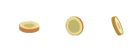
Create your Sprites
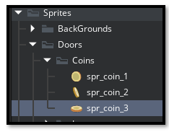
Put your Shop door into the room.

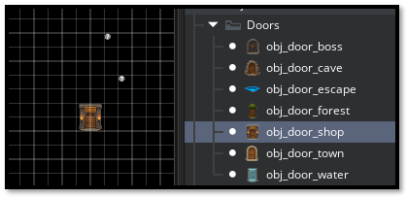

Write the code for the animation.
Update all 3 events in obj_door_shop:
- CREATE EVENT
- STEP EVENT
- DRAW EVENT

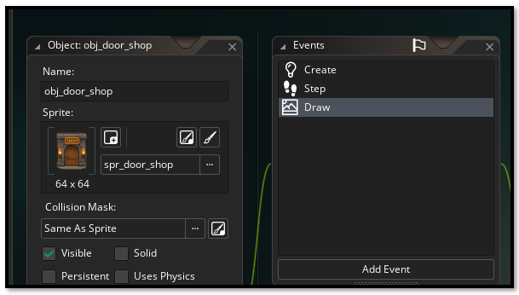

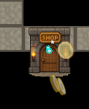

//~~~~~~~~~~~~~~ obj_door_shop - CREATE EVENT ~~~~~~~~~~~~~~~
// Initialize falling coins with golden sparkles

depth = -100;
door_type = "shop";

// Coin arrays
coin_x = [];
coin_y = [];
coin_fall_speed = [];
coin_sprite_index = []; // Which frame (1, 2, or 3)
coin_frame_speed = []; // How fast to cycle through frames
coin_frame_counter = [];
coin_alpha = [];

// Sparkle arrays
sparkle_x = [];
sparkle_y = [];
sparkle_life = [];
sparkle_size = [];

// Create 3 falling coins
for (var i = 0; i < 3; i++) {
// Random horizontal position within door area
coin_x[i] = x + random_range(sprite_width * 0.2, sprite_width * 0.8);

// Start from upper area
coin_y[i] = y + sprite_height * 0.1 + random(sprite_height * 0.3);

// Even slower fall speed
coin_fall_speed[i] = random_range(0.3, 0.6);

// Start with random sprite
coin_sprite_index[i] = irandom(2); // 0, 1, or 2

// How fast the coin rotates (cycles through sprites)
coin_frame_speed[i] = random_range(0.15, 0.3);
coin_frame_counter[i] = 0;

coin_alpha[i] = random_range(0.7, 0.9);
}

// Create 5 sparkles
for (var i = 0; i < 5; i++) {
sparkle_x[i] = x + random_range(sprite_width * 0.2, sprite_width * 0.8);
sparkle_y[i] = y + random_range(sprite_height * 0.1, sprite_height);
sparkle_life[i] = random(60); // Lifetime in frames
sparkle_size[i] = random_range(2, 4);
}

//~~~~~~~~~~~~~~~~~~~~ obj_door_shop - STEP EVENT ~~~~~~~~~~~~~~~
// obj_door_shop - STEP EVENT
// Update falling coins and sparkles

// Update coins
for (var i = 0; i < array_length(coin_y); i++) {
// Fall downward
coin_y[i] += coin_fall_speed[i];

// Animate coin rotation (cycle through sprites)
coin_frame_counter[i] += coin_frame_speed[i];
if (coin_frame_counter[i] >= 1) {
coin_frame_counter[i] = 0;
coin_sprite_index[i] = (coin_sprite_index[i] + 1) % 3; // Cycle 0→1→2→0
}

// Gentle alpha pulse
coin_alpha[i] += random_range(-0.01, 0.01);
coin_alpha[i] = clamp(coin_alpha[i], 0.6, 0.95);

// Reset coin when it falls below door
if (coin_y[i] > y + sprite_height + 10) {
coin_y[i] = y + sprite_height * 0.1;
coin_x[i] = x + random_range(sprite_width * 0.2, sprite_width * 0.8);
}
}

// Update sparkles
for (var i = 0; i < array_length(sparkle_life); i++) {
sparkle_life[i] += 1;

// Reset sparkle when lifetime expires
if (sparkle_life[i] > 60) {
sparkle_x[i] = x + random_range(sprite_width * 0.2, sprite_width * 0.8);
sparkle_y[i] = y + random_range(sprite_height * 0.1, sprite_height);
sparkle_life[i] = 0;
sparkle_size[i] = random_range(2, 4);
}
}

// ~~~~~~~~~~~~~~~~~ obj_door_shop - DRAW EVENT ~~~~~~~~~~~~~~~
// Draw falling coins with golden sparkles

// Draw the door sprite
draw_self();

// --- Draw Silver/Blue Sparkles ---
for (var i = 0; i < array_length(sparkle_life); i++) {
// Calculate sparkle alpha based on lifetime (fade in/out)
var life_ratio = sparkle_life[i] / 60;
var sparkle_alpha = sin(life_ratio * pi); // Smooth fade in/out

draw_set_alpha(sparkle_alpha * 0.8);

// Silver/blue sparkle (alternating)
if (i % 2 == 0) {
draw_set_color(c_aqua); // Blue sparkle
} else {
draw_set_color(c_silver); // Silver sparkle
}
draw_circle(sparkle_x[i], sparkle_y[i], sparkle_size[i], false);

// White center highlight
draw_set_color(c_white);
draw_circle(sparkle_x[i], sparkle_y[i], sparkle_size[i] * 0.5, false);
}

// --- Draw Falling Coins ---
for (var i = 0; i < array_length(coin_y); i++) {
// Choose which coin sprite to draw based on index
var current_coin_sprite;
if (coin_sprite_index[i] == 0) {
current_coin_sprite = spr_coin_1;
} else if (coin_sprite_index[i] == 1) {
current_coin_sprite = spr_coin_2;
} else {
current_coin_sprite = spr_coin_3;
}

// Draw the coin sprite
draw_sprite_ext(
current_coin_sprite, // Which coin sprite
0, // Image index
coin_x[i], // X position
coin_y[i], // Y position
1, // X scale
1, // Y scale
0, // Rotation (0 - coins don't rotate, just change frames)
c_white, // Color tint
coin_alpha[i] // Alpha
);
}

// Reset draw settings
draw_set_alpha(1);
draw_set_color(c_white);

The Town Door
This will be the last door, we will be doing today. The town door will have just a simple shimmer. This will tell the player which doors in town that they can enter and which doors that is just artwork, and if they were to walk into them…well, nothing really would happen.
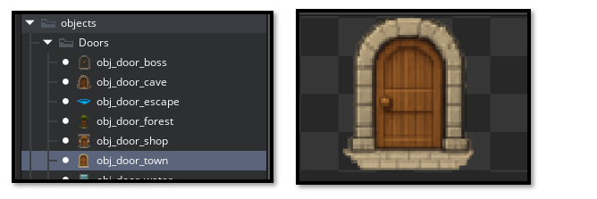

Now Drag your door into the room
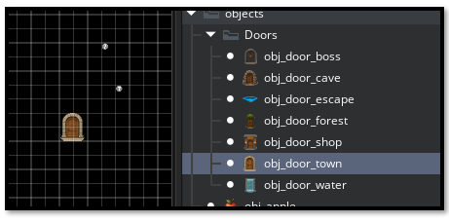

// obj_door_town - CREATE EVENT
// Simple shimmer effect with subtle sparkles

depth = -100;
door_type = "town";

// Sparkle arrays for shimmer effect
sparkle_x = [];
sparkle_y = [];
sparkle_life = [];
sparkle_max_life = [];
sparkle_size = [];

// Create 7 subtle sparkles (mix of white and blue)
for (var i = 0; i < 7; i++) {
// Random position around door edges
sparkle_x[i] = x + random_range(sprite_width * 0.15, sprite_width * 0.85);
sparkle_y[i] = y + random_range(sprite_height * 0.15, sprite_height * 0.85);

// Lifetime for fade in/out
sparkle_max_life[i] = random_range(80, 120); // Slower, more subtle
sparkle_life[i] = random(sparkle_max_life[i]);

// Small sparkle size
sparkle_size[i] = random_range(1.5, 3);
}

// ~~~~~~~~~~~~~~~~ obj_door_town - STEP EVENT ~~~~~~~~~~~~~~~~~~
// Update shimmer sparkles

// Update each sparkle
for (var i = 0; i < array_length(sparkle_life); i++) {
// Increment lifetime
sparkle_life[i]++;

// If sparkle has completed its cycle, respawn it
if (sparkle_life[i] >= sparkle_max_life[i]) {
sparkle_x[i] = x + random_range(sprite_width * 0.15, sprite_width * 0.85);
sparkle_y[i] = y + random_range(sprite_height * 0.15, sprite_height * 0.85);
sparkle_max_life[i] = random_range(80, 120);
sparkle_life[i] = 0;
sparkle_size[i] = random_range(1.5, 3);
}
}

//~~~~~~~~~~~~~~~~~ obj_door_town - DRAW EVENT ~~~~~~~~~~~~~~~~~
// Draw subtle shimmer sparkles

// Draw the door sprite
draw_self();

// Draw sparkles with smooth fade in/out
for (var i = 0; i < array_length(sparkle_life); i++) {
// Calculate alpha based on lifetime (smooth fade in and out)
var life_ratio = sparkle_life[i] / sparkle_max_life[i];
var sparkle_alpha = sin(life_ratio * pi); // Smooth sine wave fade

draw_set_alpha(sparkle_alpha * 0.6); // Subtle intensity

// Alternate between white and light blue sparkles
if (i % 2 == 0) {
draw_set_color(c_white); // White sparkle
} else {
draw_set_color(make_color_rgb(176, 224, 230)); // Powder blue sparkle
}
draw_circle(sparkle_x[i], sparkle_y[i], sparkle_size[i], false);

// Tiny bright center
draw_set_alpha(sparkle_alpha * 0.9);
draw_circle(sparkle_x[i], sparkle_y[i], sparkle_size[i] * 0.4, false);
}

// Reset draw settings
draw_set_alpha(1);
draw_set_color(c_white);

